Cover Page
Fill out and attach to your manuscript — DUE SUNDAY, August 31, 2025

22nd International Conference on Atomic Processes in Plasmas (APiP2025)
and
1st NIFS Conference on Atomic and Molecular Processes in Plasmas

Presentation Number: | xxx (I-2, O-3, P-4, etc.)
Paper Title: | A Sample Manuscript for APiP2025
Corresponding Author: | Firstname M. LASTNAME
Affiliation: | University of Plasma
Full Postal Address: | 322-6 Toki, Gifu 509-5292, Japan
Telephone: | +81-572-58-0000
Fax: | +81-572-58-0001
E-mail: | xxxyyyzzz@u-plasma.ac.jp

A Sample Text for Proceedings Preparation
Author name should be centered 12-point Times Font type
Author’s name should be in order of given name, middle name initial and family name.

Author affiliations should be centered 10-point italic type

The abstract should be 10 point justified type with a 5 mm indentation (both of left and right) and within the 200-word limit. It should be an explicit summary of the paper that states the problem, the methods used, and the major results and conclusions. It should also contain relevant key words that would allow it to be found in a cursory computerized search. The first line should be indented 5 mm from the left margin.

Keywords: Five to ten keywords or phrases should be given. Except in special cases, type all keywords in
lower-case letters separated by commas. They should be 10 point justified type with a 5 mm indentation.

1. Introduction
The 22nd International Conference on Atomic Processes in Plasmas (APiP 2025) is organized in cooperation with the International Atomic Energy Agency (IAEA). Since 1977, the APiP conference has focused on atomic processes that are involved in the study of various plasmas over a wide range of densities and temperatures (eV to a few keVs). The topics cover Astrophysical plasmas; Fundamental Data and Modeling; High Energy Density Plasmas; Low Temperature and Industrial Plasmas; Magnetic-Fusion Plasmas; Measurements of Atomic Processes; Powerful Light Sources (XFEL, etc.); Small-scale Plasmas (table-top lasers, EBITs, etc.); Warm Dense Matter.
This time the NIFS conference is jointly held with the APiP conference and various atomic and molecular processes in fusion plasmas are focused to discuss in particular. We hope to bring researchers in fusion plasmas to this conference to join the discussion and find new sights on plasma physics.
2. Journal publication
Original articles related to the conference topics, are encouraged to be submitted to Plasma and Fusion Research (PFR) which is an electronic journal published by the Japan Society of Plasma Science and Nuclear Fusion Research. The papers will go through a complete peer-review process. Only the papers reporting original and previously unpublished work will be accepted and published as “Regular” articles in the academic journal, PFR. In general, a publication fee is required (30,000 JPY per paper + 10,000 JPY per page). However, we will waive the fee for papers up to 4 pages in length for approximately 15 submissions. The fee waiver will be granted on a first-come, first-served basis, with priority given to invited and oral speakers. Sample format for the manuscript is available on the APiP2025 Web site.
Note: The first author of the publication paper is expected to be the same as the first author on the presentation at the conference.
3. Paper preparation
This document is a journal-page image for Microsoft Word versions 6.0 or later. Author/s may use this file to check total length of the manuscript in a printed image, equations (especially lengthy equations to be separated into multiple lines), tables and figures (font sizes should be checked), and references. If you are reading a paper version of this document, please download the electrical file from https://yebisu.ils.uec.ac.jp/apip2025/. If you would prefer to use LATEX, download a style file and sample files from the Web page above. PFR recommend Postscript font for preparation of manuscript. However if these font are not installed on your computers, font replacement like Time => Times New Roman, Symbol (Postscript) => Symbol (True type), Helvetica => Arial is accepted.
This style guide has been written to allow authors to use almost any word processing, page layout, or typesetting software that can print to a PostScript printer or output PostScript to a file. It is essential to use an appropriate PostScript printer driver to generate the compuscript file for submission. Most, but not all, PostScript printer drivers will generate proper output. Please see the help files of JSPF Web page for information on recommended drivers and installation instructions.
Paper size should be A4 (21.0 x 29.7 cm). The length of an article can be calculated by allowing 900 words per page in an A4-sized journal. The layout of a manuscript, such as margins (top, bottom, left and right) and two-column style, should follow the setting of this Sample Text. When you submit your final version, check the total length of your paper in this two-column format, including figures and tables. As the format can show the approximate page length of the manuscript, the page length of the published paper might be changed in some degree.
All fonts for text should be Times or Times New Roman and Symbol. Text should be 10 pt., the title should be 18 pt., and the affiliation and references should be 10 pt. Do not use hyphenations for the end of a line. The line space of main text should be 13 pt., while that of Title should be 22 pt.
Major headings (“Head 1” in the template style list) are bold 11-point font, flush left, and numbered (1. 2. 3. etc.) Subheadings and Sub-Subheadings are bold, flush left, and numbered as 1.1, 1.2, etc. and as 1.1.1, 1.1.2, etc., respectively. In Rapid Communications and Letters, section headings may not be necessary or permitted. The first line of the first paragraph of a section or subsection should start flush left. The first line of subsequent paragraphs within the section or subsection should be indented 7 mm.
When you open sample.doc, select "Page Layout"(“Insatsu Layout”) from the "View"(“Hyouji”) menu in the menu bar. Then type over sections of this file or cut from another document and paste and then use markup styles. The pull-down style menu is at the left of the Formatting Toolbar at the top of your Word window (for example, the style at this point in the document is "text"). The style will adjust your fonts and line spacing. Do not change the font sizes or line spacing to squeeze more text into a limited number of pages. In footnotes section, you are requested to write corresponding author’s e-mail address.
5. Equations and Figures
Use either the Microsoft Equation Editor or the MathType add-on for all math objects in your paper. "Float over text" should not be selected. A math object is any equation or fragment containing mathematical symbols (including Greek characters, superscripts and subscripts) that appears either in-line (in the flow of normal text) or as a display equation (in its own space between lines of text).
In particular, you should avoid using Word fonts or symbols for in-line single variables with superscripts or subscripts. Use italics for emphasis; do not underline.
The MathType add-on for Word is a commercial product. If you have MathType, use it for as much of your math as possible. If not, use the Microsoft equation editor, which comes as part of Word.
Equations should be indented 10 mm. Equation numbers should appear at the right-hand margin, in parenthesis. For long equations, the equation number may appear on the next line. For very long equations, the right side of the equation should be broken into approximately equal parts and aligned to the right of the equal sign. The equation number should appear only at the right hand margin of the last line of the equation. For example,

$\tilde{f}(\text{x,} μ,E)=-ρ⋅∇f_{M}(\text{x,} E),$ (1)
where $ρ={b×v_{⊥}}/Ω$.
$\begin{aligned}\int{F_{\text{ij}}}(r,ϕ)\text{dr}dϕ=\left[{σr}_{2}/\left(2μ_{0}\right)\right] \\ ×\int{ \text{exp}\left(-λ\left|z_{j}-z_{i}\right|\right)λ^{-1}J_{1}\left({λr}_{2}\right)}dλ \text{.}\end{aligned}$ (2)

Figures should be included directly in the document. All photographs must be in digital form and placed appropriately in the electronic document. All illustrations must be numbered consecutively with Arabic numbers. The size of a figure should be commensurate with the amount and value of the information conveyed by the figure.
PFR accepts video and audio as separate files. Color printing of figures is also available. If you want to use color figure on paper printing, this cost shall be billed to the authors.
Place figure captions below the figures. The captions should be indented no margins. The abbreviation “Fig.” for figure should appear first followed by the figure number and a period. Captions should be in 9 pt. Roman Font.
References
PFR follows the following citation style: For journal articles, authors are listed first, the volume number in bold, inclusive page numbers, and the year in parentheses. If you have any question for this style, please contact to the publication office of PFR (journal@jspf.or.jp).
References should appear at the end of the article. The font should be 9 pt., aligned left. The words “References” should not head the section in Rapid Communications and Letters. All references should be indented no margin, with succeeding lines indented sufficiently to preserve alignment. The line space of this part should be 12 pt.
PFR uses numerical notations in brackets for bibliographic citations. At the point of citation within the main text, designate the reference by typing the number in after the last corresponding word [1]. Reference numbers should precede a comma or period [2]. Two references [3,4], should be included together, separated by a comma, while three or more consecutive references should be indicated by the bounding numbers and a dash [1-4].
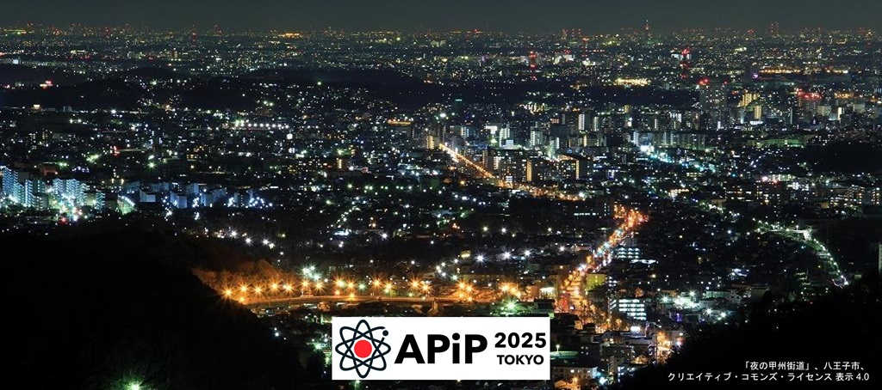
Fig.1 Sample figure. Note how this figure caption is indented by 1cm from the left margin.

- Y. Kitazawa and K. Sugiyama, J. Plasma Fusion Res 16, 40 (2001).
- M. Furukawa et al., Plasma Fusion Res. 1, 001 (2006).
- L. Spitzer, Jr., Physics of Fully Ionized Gases (Interscience Publishers, New York, 1959) p. 20.
- N. Kimura et al., Plasma Fusion Res. 14, 1201021 (2019).

